Created GITHUB ACCOUNT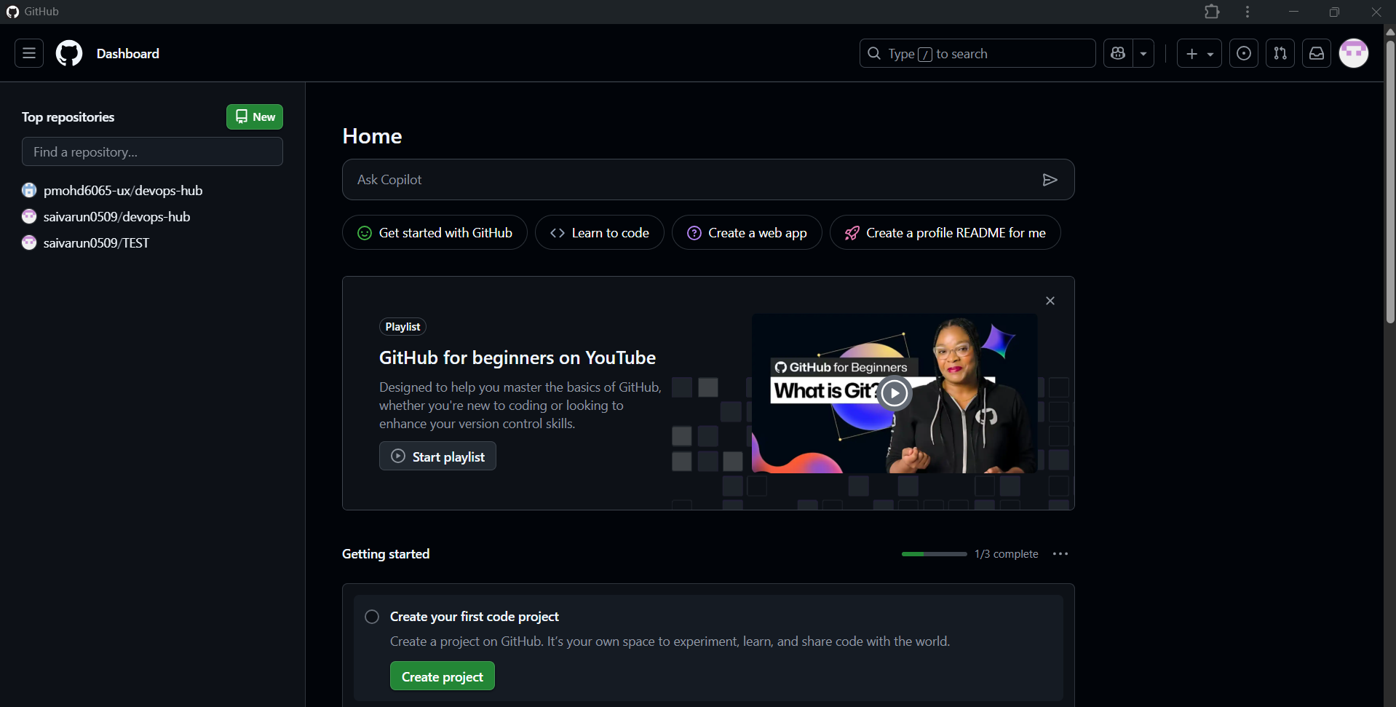

MFA Setup

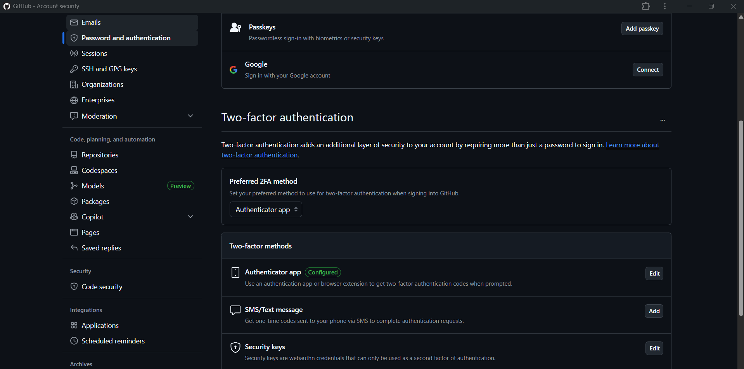

git –version [To know git version]

git init [To initialize git]

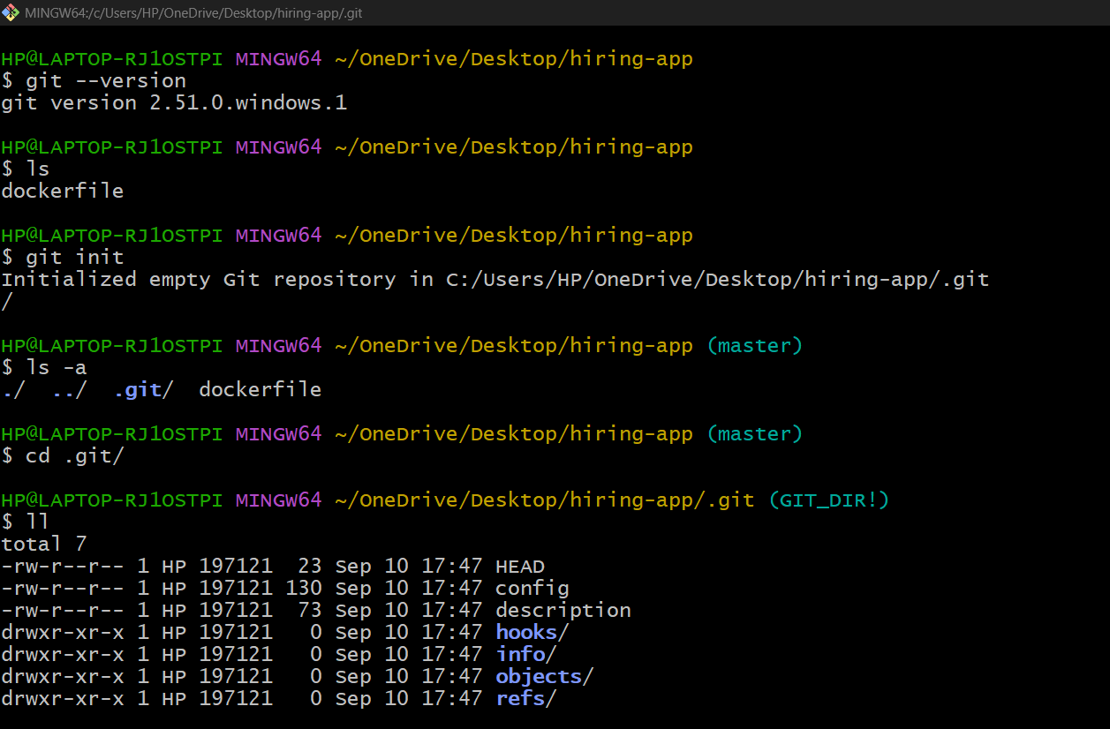

git status [To track the changes in particular repository]

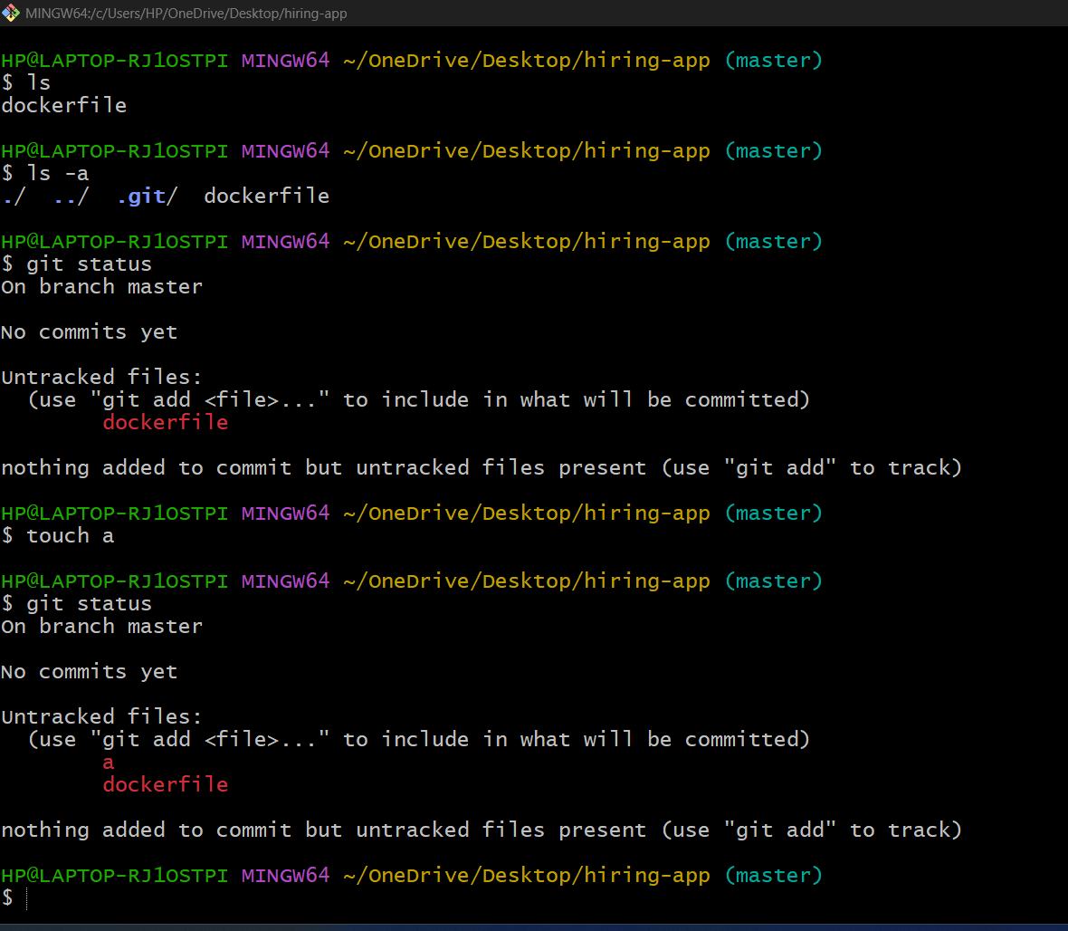

git config - -list [It shows configuration details]

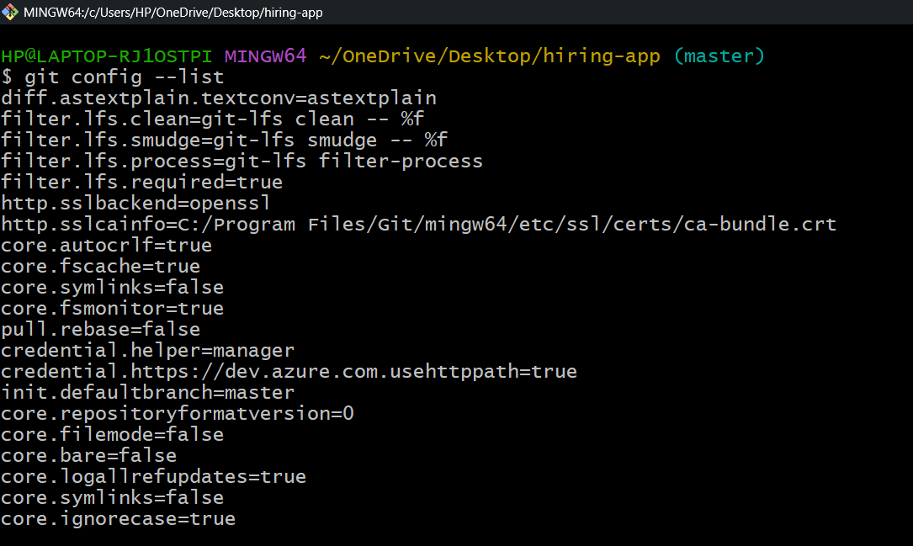

git config - -global user.name "username" [To add username]

git config - -global user.email “gmail” [To add gmail]

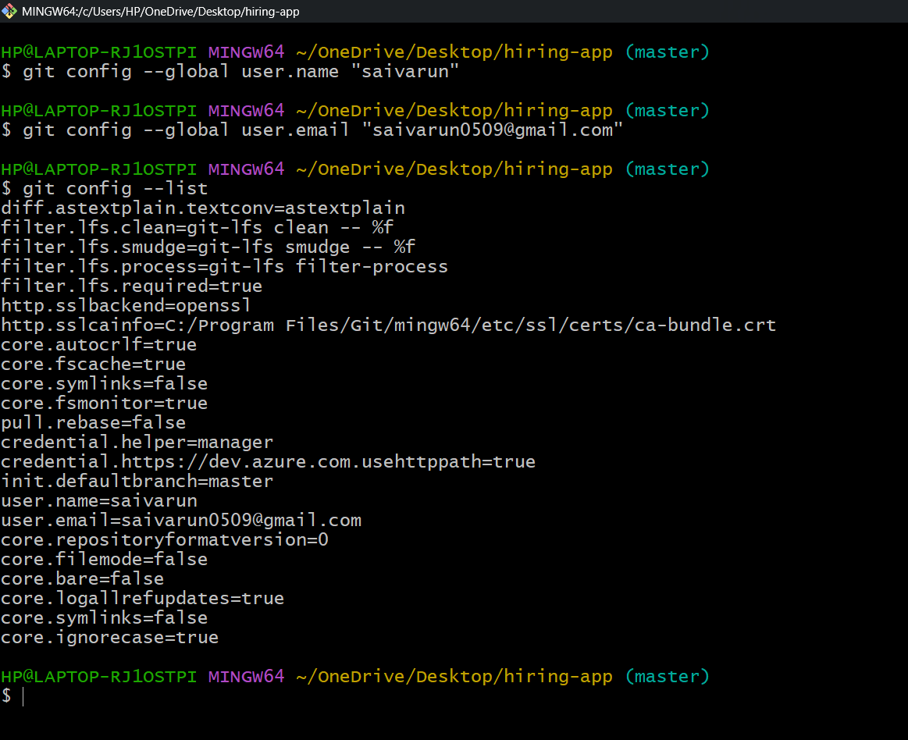

git add filename [It adds file from untracking area to tracking area]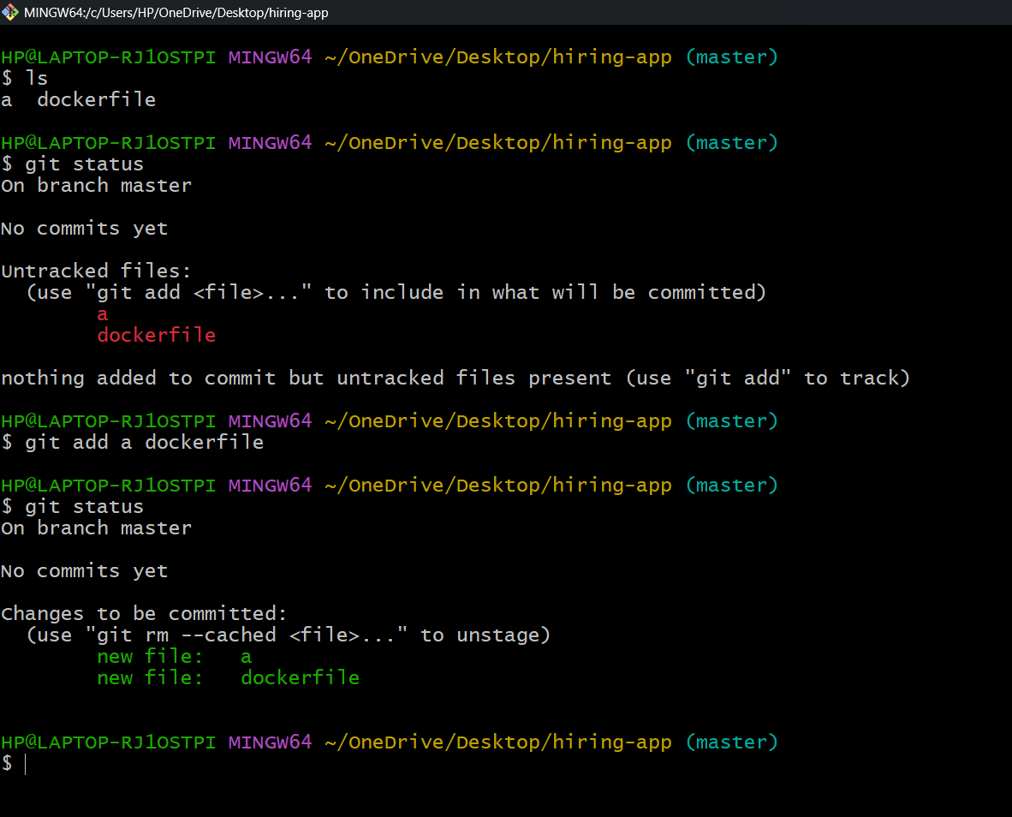

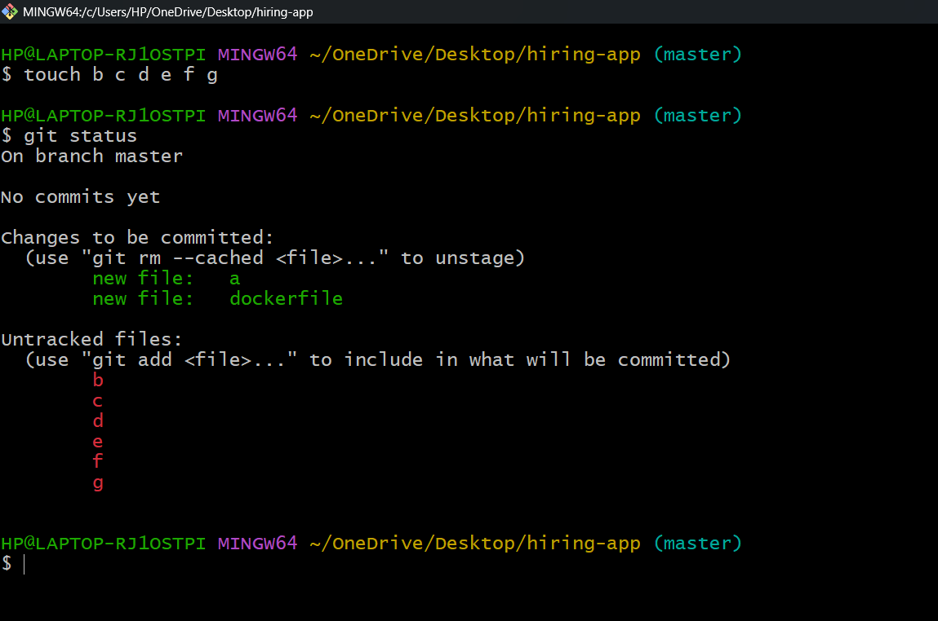

git add . [ It adds all files from untracking area to tracking area]

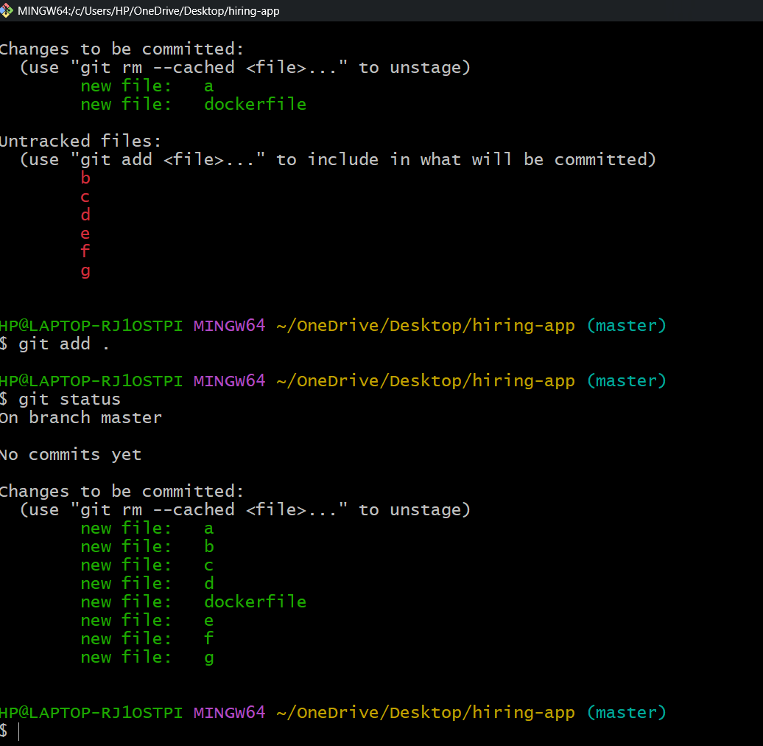

**git commit -m “message” [It will store a copy of changes with commit id]**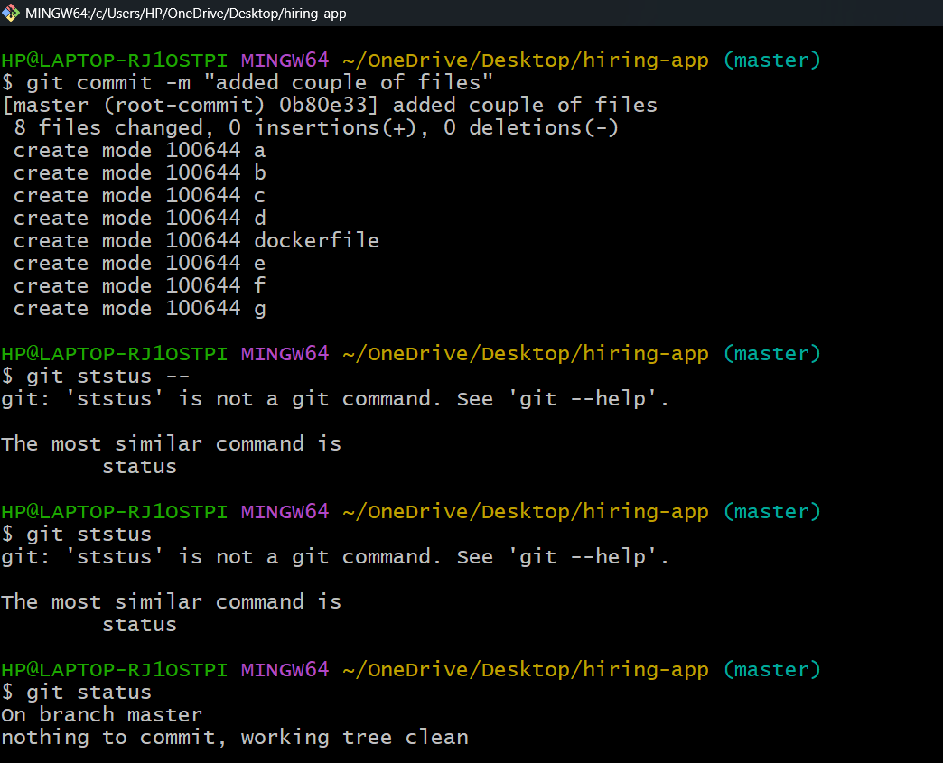

**git log [It will show the previous commit/changes that   
have made]**

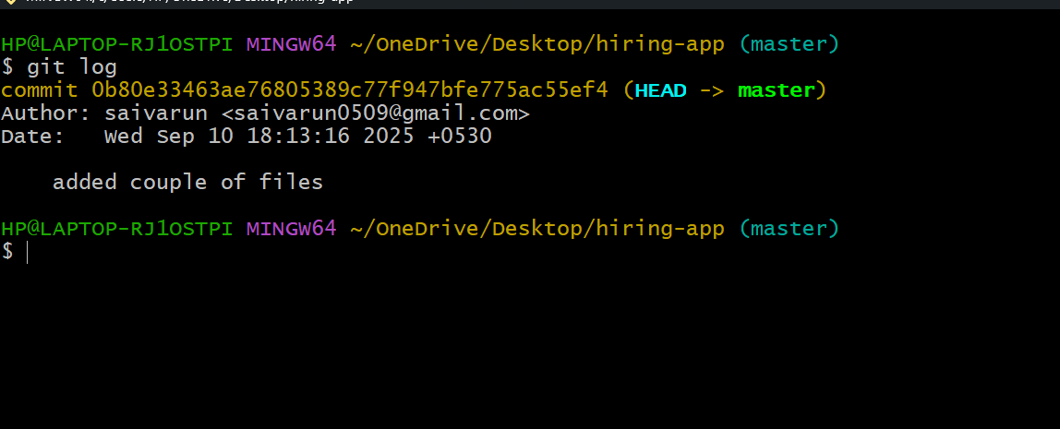

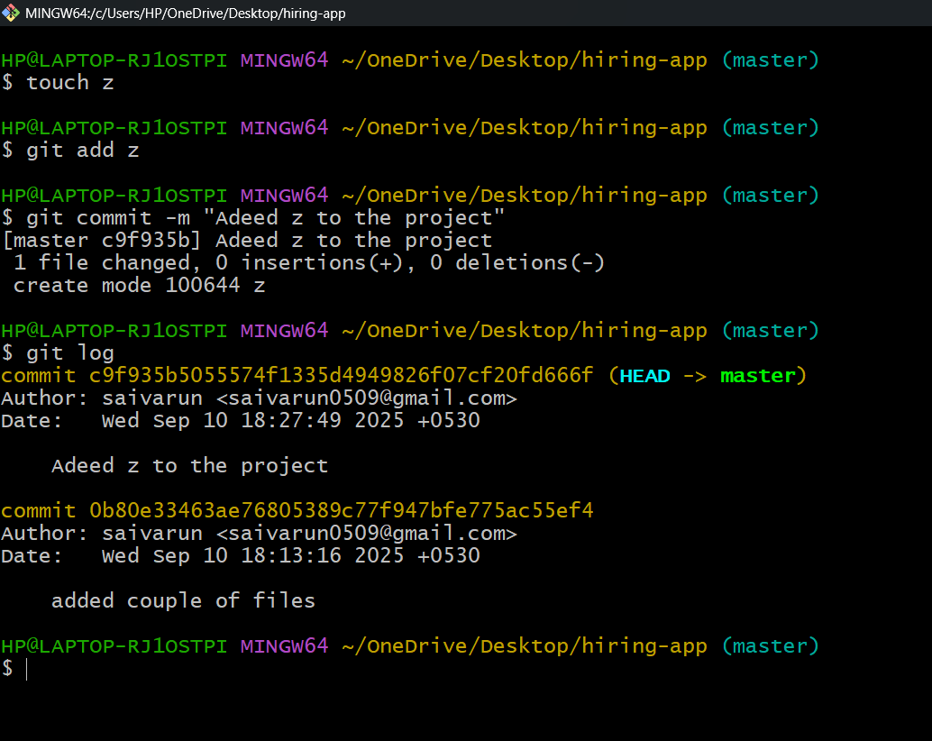

**git remote add origin SSH-GitHub-URL [It will add GitHub repo]**

**git remote -v [It shows list of GitHub repo that have added before]**

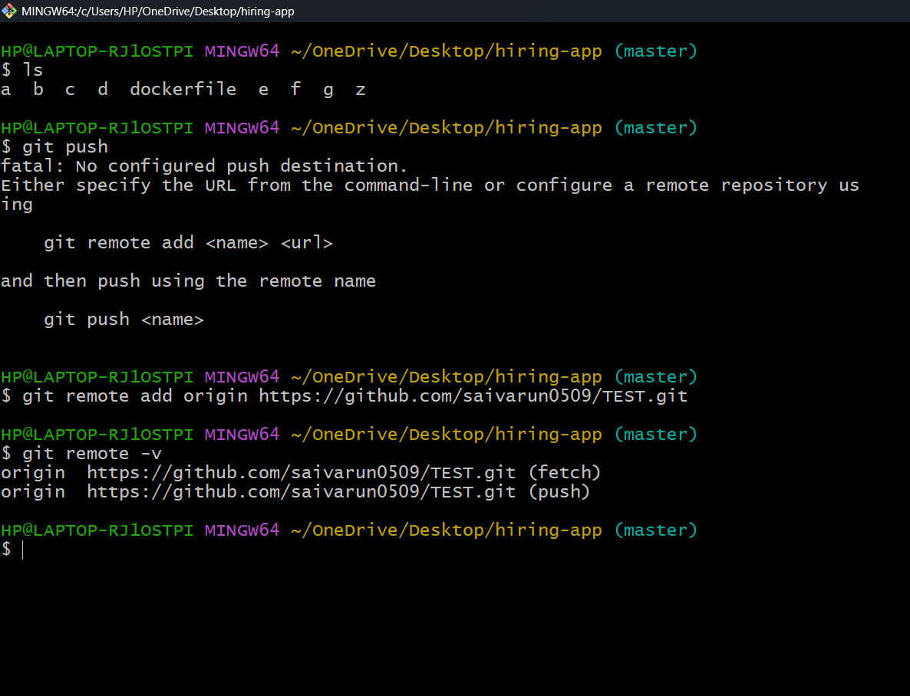

**git push -u origin master / git push [It will push changes to GitHub repo]**

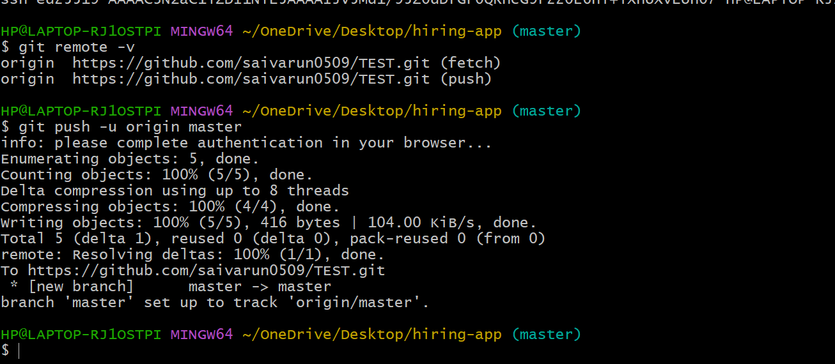

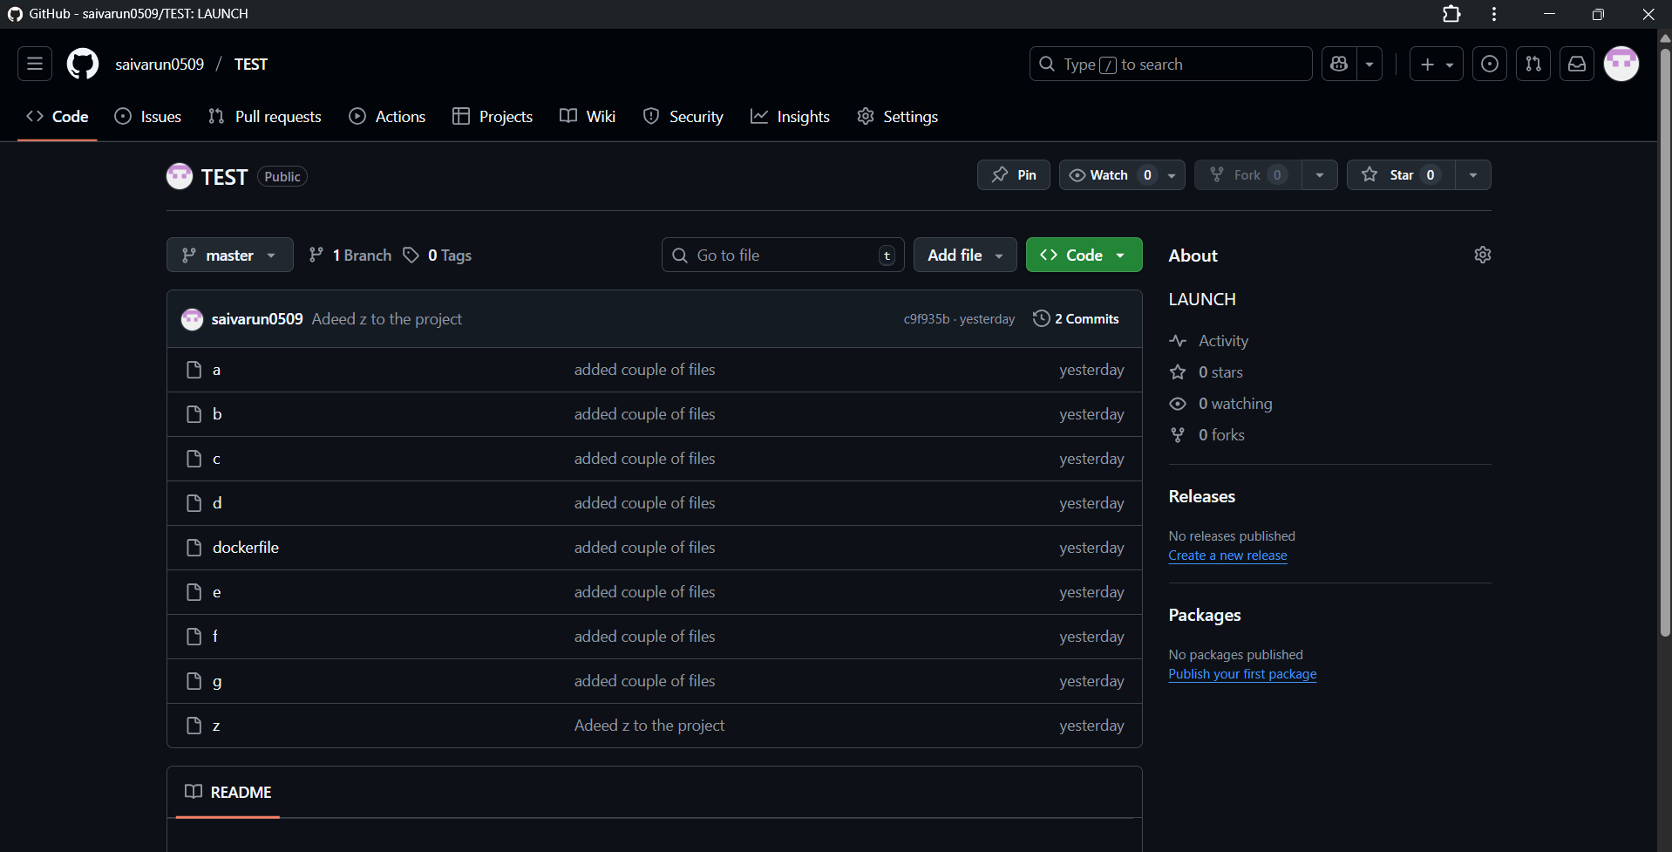

**git pull [It will pull changes from GitHub repo to our Git repo]**

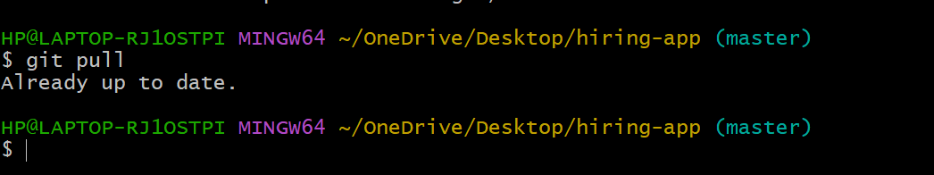

**git clone github-repo-URL [ It’ll download all data from GitHub]**

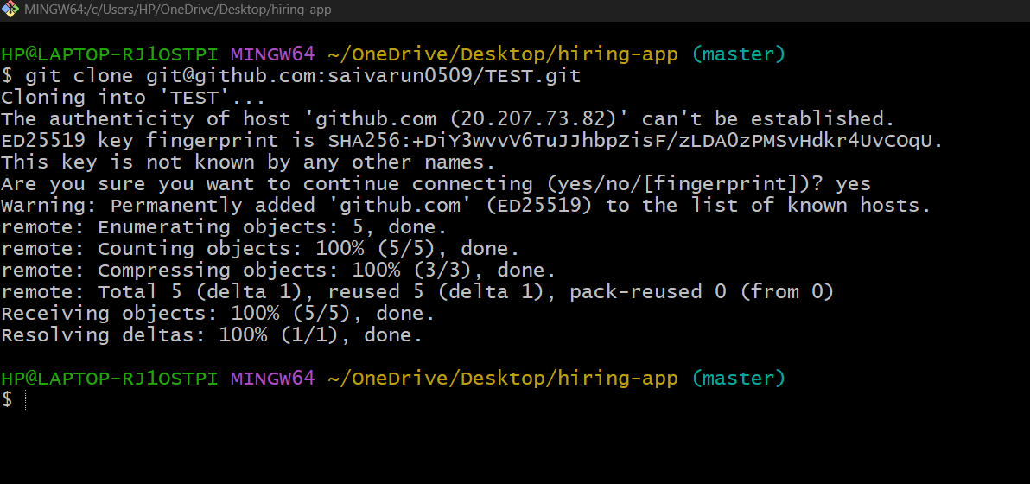

**git revert <commit_id> [It will try to go to previous commit]**

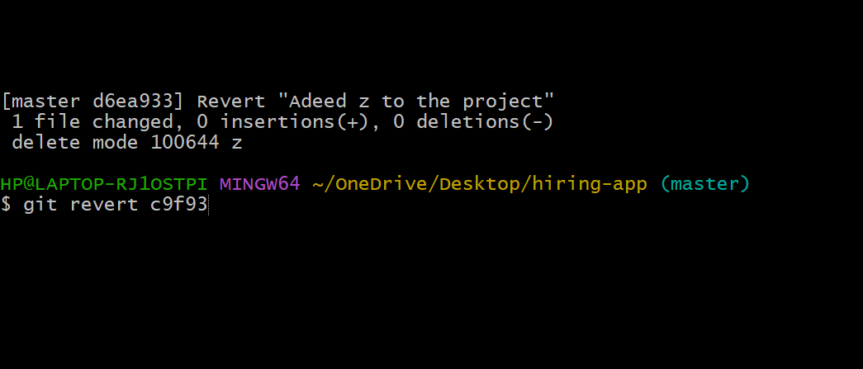

**Ssh-keygen [To generate key pair]**

